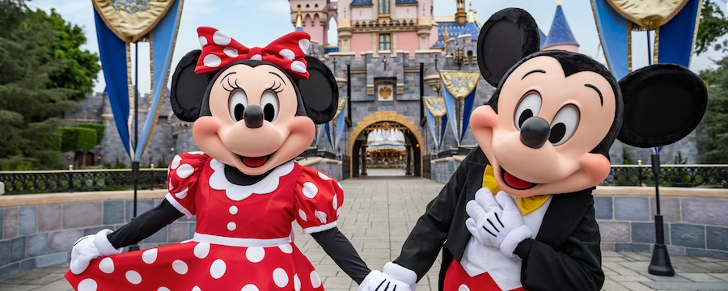
Knuffle Bunny is lost. Write a Postcard to Trixie from where Knuffle Bunny is.
Cut and paste one of these pictures to the postcard or draw your own.
Dear Trixie, I am in Paris on the Effel Tower…
Dear Trixie, Guess who I just met?...
Dear Trixie, I am swinging through the vines of the jungle….
Cute and glue the place where Knuffle Bunny is. Draw your own place if you’d like.
Don’t forget to end the post card with
Love and a miss you, Knuffle Bunny.
